The Rule of Three
Emmanuel is a great poet. In the city he won women and praise. Tonight, he tells stories for his supper in a rustic inn where none have heard of him.
Josephine is a scriptwriter making a pitch. It has strong characters and clever props … but no plot.
Grignar is a savage in a strange land. As he hides in a harem, deceptively doe-eyed harridans ask him about his adventures.

This is a game of stories, storytellers and their meddlesome audiences.

In the Rule of Three, you and your friends pretend to be storytellers and their audience. Those characters tell stories to one another.
Every story requires cooperation. Without an active audience the story will be weak and predictable.
You and I would never interrupt a story. But in this game, we are Josephine and the movie executives; Grignar and the harem girls; Emmanuel and the tavern’s clientele. They interrupt, they question and they contradict.
That makes this game work.

Run down
In an ordinary game of the Rule of Three, you’ll gather one or more friends.
You’ll discuss what sort of story you want to tell (‘science fiction’ or ‘set in the 50s’) and also decide what storytellers and audience you will play (‘bored housewives swapping gossip’ or ‘alien historians’).
You’ll create a seed for your story and fertilise that seed with facts, contradictions, questions and controversies.
Finally, you’ll tell the story from the perspective of your characters.
Storytellers and audience both participate. Storytellers set the scene and describe what happens, but the audience constantly butt in with questions, comments and contradictions.
This creates a wonderful and unpredictable story.

Details
By Chris Sakkas in 2011.
Email the author at <sanglorian@gmail.com>.
This work is licensed under the Creative Commons Attribution-ShareAlike 3.0 Unported License.
Written for Daniel Solis’ Thousand-Year Game Design Challenge, <http://www.thousandyeargame.com/>

Setting (step one)
In this step, you and your friends decide what type of story you will tell and which characters you will tell it with. The story and the storytellers don’t need to be in the same setting.
Type of Story: As specific as you want. ‘Fantasy’ or ‘Post-bellum North Carolina in the gutted remains of a plantation house’.
Characters: Who is telling the story and who’s listening to it? Each one of you is going to pretend to be a storyteller or an audience member, so make them distinctive and interesting.
Each character’s name should fit their mood and personality. A fantasy story may have Danae the Bold and Fey Emile. Perhaps a modern story could have James Moody and Cassie Sly.

At the end of this step, you should write down:
- Who is playing which character.
- Which character begins as the storyteller.
- What type of story the storyteller and audience are telling.

Premise (step two)
In this step, you will create the seed for the story and fertilise that seed with ideas and details.
Pattern: A pattern gives you gaps for you to insert words. The most common is: “[addition] [noun] [verb] [addition] [noun]”.
A seed from this pattern could be: ‘Fiery Woman Leaves Rich Janitor’.
Creating the seed: The storyteller writes a word (‘an element’) into one of the slots in the pattern.
The audience members when write words in the other slots until the pattern is full.
Noun: A person place or thing. ‘Ogre’ or ‘Woman’.
Addition: An adjective or noun which adds detail to a noun card. ‘Small Ogre’ (adjective) or ‘Farmer Woman’ (noun).
Verb: An action or mood. ‘Small Ogre Loves Farmer Woman’ or ‘Farmer Woman Lost Small Ogre’.
Reading the elements: After the seed is finished, people can read the elements by …
Adding facts: The storyteller or audience member states a sentence about the seed.
For example, ‘The Ogre lost his leg to a bear trap’.
Twisting facts: An audience member can say ‘yes but …’, ‘no but …’ and ‘yes and …’ about any fact to change it in some way.
For example, for ‘The Ogre lost his leg to a bear trap’ you say, ‘No, but it was mangled and scarred’.
Asking questions: Audience members can also ask questions about the seed which will be answered by the end of the story.
For example, ‘Will love triumph over prejudice?’
Finishing up: When everyone agrees that you have the seed for a good story, each person writes down three things that might happen during the course of the story (‘the complications’). Shuffle these together and give three to each person.

At the end of this step, you should write down:
- What the seed is.
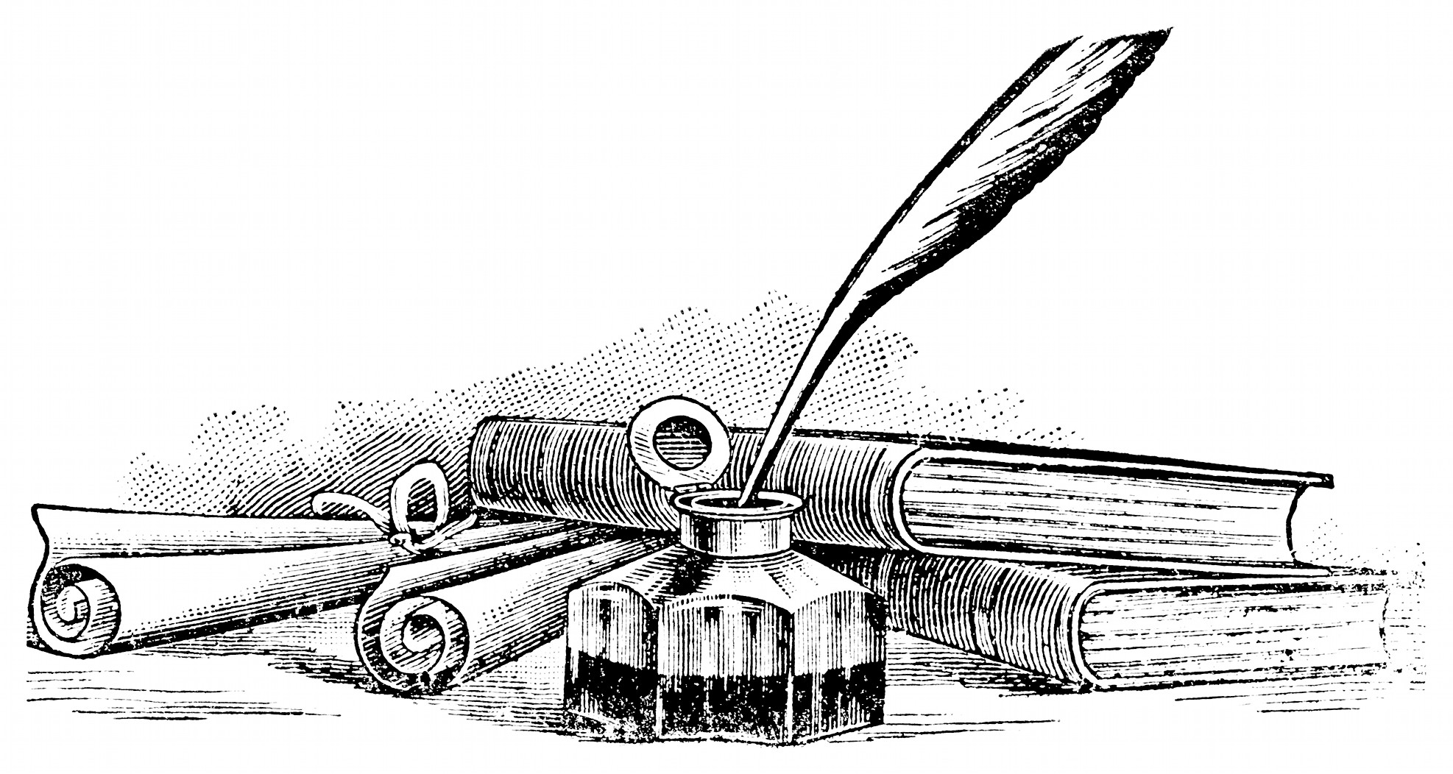
- How the elements have been read.

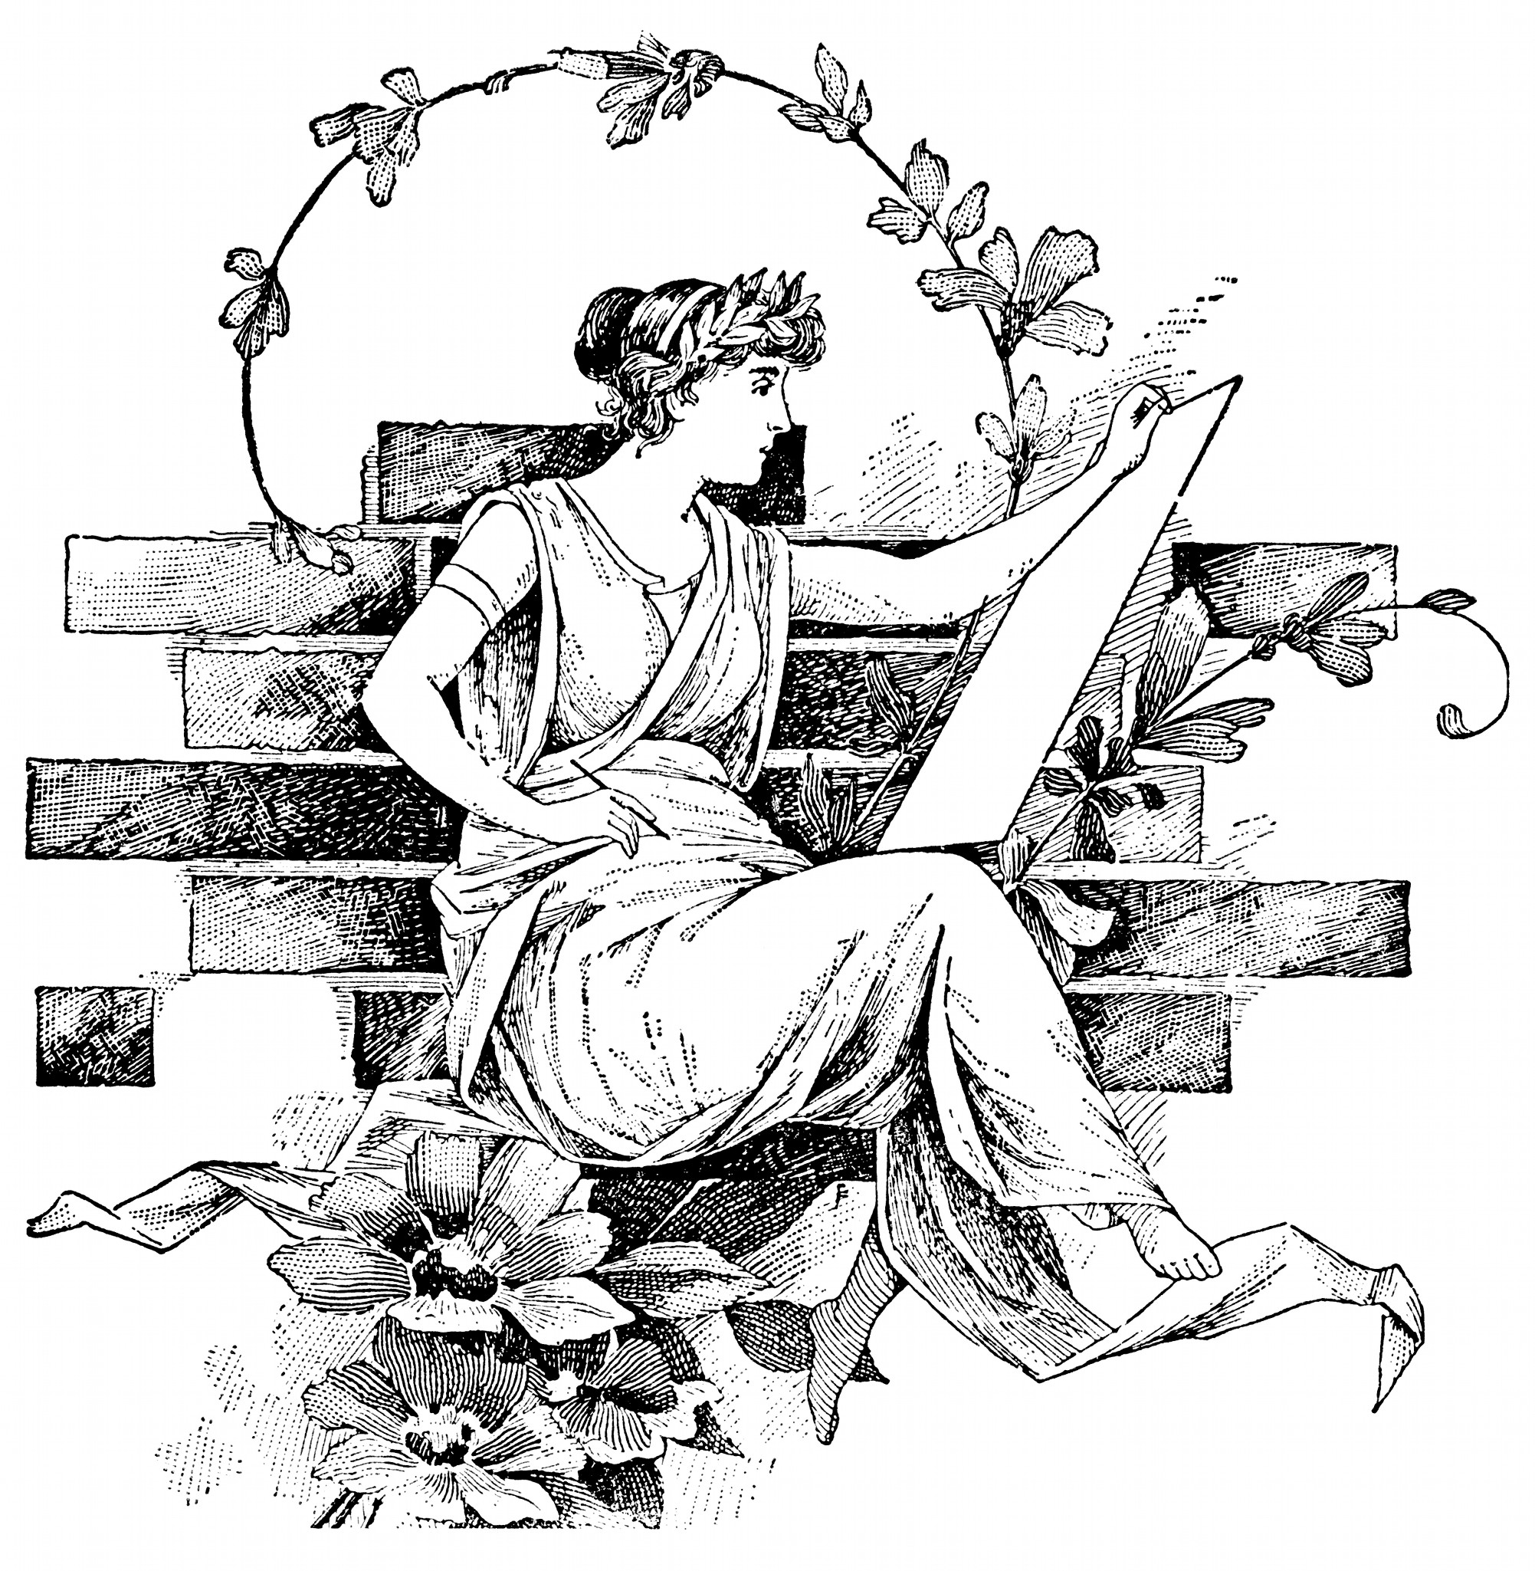
Step Three: Story
The storyteller sets the first scene and describes what happens.
The audience members will take over parts of the story, challenge the storytellers and ask questions.
Together, a story emerges.
The End: When everyone agrees, the storyteller ends the story.
Ritual phrases: Storytellers and audience members have special phrases they can say at any stage.

Ritual phrases for storytellers
‘I struggle to remember’: You ask the audience to contribute ideas or answers.
‘I know not the rest’: You want to give up the storyteller role when an audience member is ready to take over.

Ritual phrases for both
‘It will become known’: You ask a question which will be answered by the end of the story.
‘I need a moment’: You want to pause the game.
‘I am uncomfortable’: You ask the storyteller to change part of their narration or an audience member to change his or her contribution.

Ritual phrases for audience members
‘I know this one best’: You take over the action and dialogue of a character.
‘I have something to add’: You add a character, event, complication, detail or anything else to the scene.
‘I know the rest’: You want to take over the storyteller role when the current storyteller is ready.
‘It was not that simple’: You change the narration by saying ‘Yes and …’, ‘Yes but …’ or ‘No but …’
‘I want to hear more about …’: You want the storyteller to expand on a character, moment or action.
‘And then …’: You introduce one of your three complications and describe it.

